COMP1710/COMP6780: Laboratory 1

**Use of the labs, Linux, email, digital images, and art**

# Objectives

The purpose of this lab is to introduce you to the basic tools you will be using during this semester. There is nothing complex here, and some of you may already know most of the procedures. The goal of this lab is that by the end, everybody should be able to attend other labs, access their student accounts and use the tools, and email.

Specifically, you will:

* use the Chrome browser to read WWW resources (including COMP1710 materials) to browse the web,
* enroll in the COMP1710/6780 Piazza forum,
* work with digital images (some we provide, some you will find) including opening, editing, copying and re-sizing,
* upload your assignment.html page into your public_html space of your account on Partch, and
* produce some art using a tool we provide.

MOOC online learning for week 1 is still open this week, and MOOC online learning for week 2 is now open also. Please be sure to do the quizlets by the end of the week!

# Tasks

* 1. **Your account on Partch**

All your assignments will be submitted via your account on Partch, and it requires you have logged into the Computer Science Student Registration and Marks System (StReaMS) beforehand. If you have not yet done this, please log into StReaMS at <https://cs.anu.edu.au/streams/> then logout again.

## Upload assignment.html to Partch

* + - 1. On your Desktop, create a folder called COMP1710
      2. Inside the folder COMP1710, create a folder called Lab 1
      3. Download assignment.html page from Wattle, and save it to folder Lab1
      4. Follow the steps documented in COMP1710 Submission Guide 2022.pdf to upload assignment.html to your Partch account
      5. Use a browser to access the uploaded assignment.html under your Partch account (e.g. by opening

<http://partch.anu.edu.au.virtual.anu.edu.au/~uxxxxxxx/assignment.html>)

## Upload a folder to Partch

* + - 1. Inside the folder Lab1, create a folder named Images
      2. Download the following two images and save them to folder Images that you have just created

<https://images.unsplash.com/photo-1658246944434-04b7ec2cb7f7>

* + - 1. Follow the submission methods documents in COMP1710 Submission Guide 2022.pdf to upload the folder Lab1 and all files underneath to your Partch account
      2. Open [http://partch.anu.edu.au.virtual.anu.edu.au/~*uxxxxxxx*](http://partch.anu.edu.au.virtual.anu.edu.au/~uxxxxxxx) *(uxxxxxxx being replaced by your university id)* in a browser, making sure
         1. you can access assignment.html
         2. you can access the two images

# Enroll in COMP1710/6780 Piazza forum

We use Piazza forum to ask and answer questions. It is also part of your assessment to actively participate in the Piazza forum, so this task is making sure you have

enrolled in the forum.

1. Use a browser to open [https://piazza.com](https://piazza.com/).
2. Sign-in to your Piazza account or create an account if you don’t already have

one.

1. Click the dropdown arrow on the top left corner, and select “Add Class”

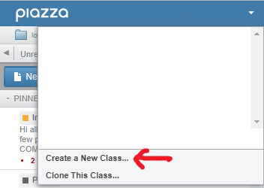

1. For “Selected Term”, choose “Spring 2021”
2. Type “COMP1710” and a dropdown option for our class will appear. Click “COMP1710/6780: Web Development and Design 2021”.
3. Click “Join Class” button at the bottom to enroll.

# Digital Images

## Working with images online

This exercise is to start familiarizing you with working with images online. Please download the image to use via the following link and rename it to “*Comp1710_Lab1_TestImage1”*:

<https://images.unsplash.com/photo-1658246944434-04b7ec2cb7f7>

The following instructions are based on a Linux environment. For Windows users, feel free to find equivalent tool to fulfill the tasks.

Open *Comp1710_Lab1_TestImage1.jpg* in Preview (doubleclick filename in the explorer window) and view image properties (Click on the three horizontal lines stacked on the right corner. Then click on the).

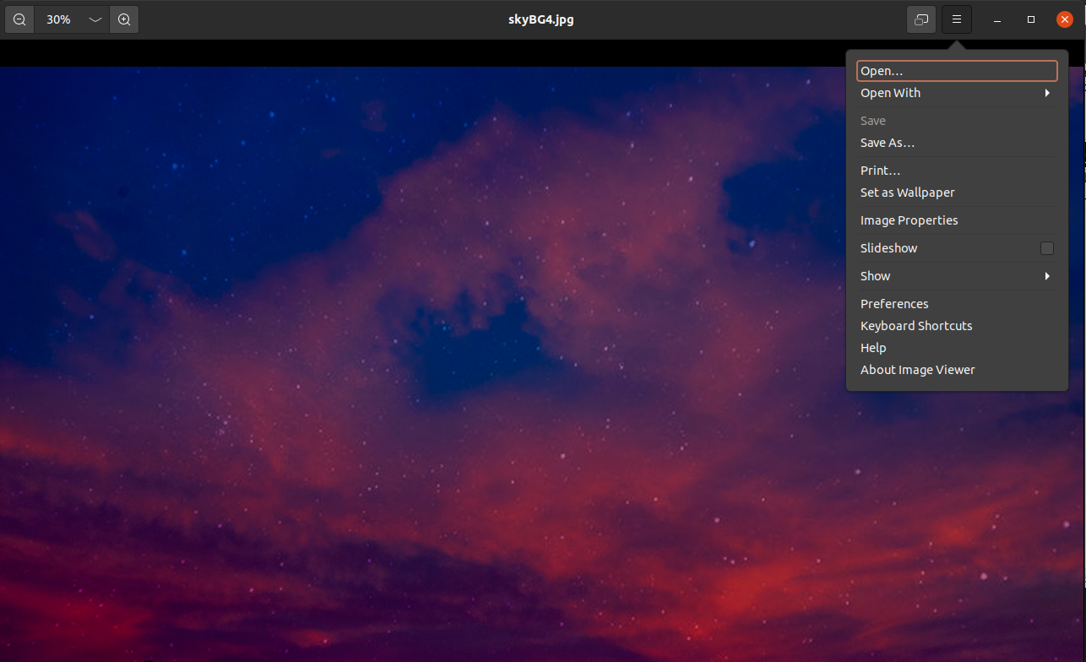

How many pixels is it horizontally?

Vertically? What is its resolution?

Go to the Internet and search for sites that offer images free to use. (Be careful that you do not mistake ‘free to use’ with subscription sites that say ‘free to use’ but mean only once you’ve subscribed and paid a monthly fee). For each site, note the name of the site, the URL, and the conditions of use. You should find a site or sites that offer:

* Stock photos,
* Clipart and other non-photo graphics,
* Vector graphics, and/or
* Animated graphics

Copy one or more free images to your Comp1710 directory and view in Preview. Experiment with zooming in and viewing metadata to get a feel for the differences in size and resolution.

## Image websites comparison

This exercise is to get you familiarize with evaluating image websites and choose the right website to get images.

* + - 1. Please form a group of 2 to 3 students and introduce yourselves to each other.
      2. Ask your tutor to provide you with two image websites to compare.
      3. Open each website, look at the photos they offer, read through the conditions for use, and discuss which website is better for students.

Some things for you might like to consider are:

* Are there a lot of images? About how many?
* Are the images categorised in a way that makes it easy to find what you want?
* Is there a subscription fee? (Some sites say the images are ‘royalty free’ but you still have to subscribe to the service and/or buy the images individually.)
* How do they expect you to attribute the image(s) you use on your site?
* Do they use Creative Commons licensing? (Refer to Monday’s lecture for more about Creative Commons.)
* Other things you think are important.

There is a posting from **David Flores-Condezo** on the **Piazza Student Forum** for our course about reflections on image sites. If during the lab you post a reply to that message with the details for which two sites you are evaluating (name and URL), which site

you prefer and why you prefer it (by answering the questions above), you will get full marks for this post as one of your three best posts in the Student Forum.

The details needed are:

* Group members (your names)
* Names of the two websites
* URLs of the two websites
* Your preference as a group and reasons

# Work ahead

If you have reached this point and you want to keep going productively, I have 2 suggestions. In future labs, we will use techniques from the lectures, such as web links, CSS, forms etc. To get started in becoming familiar with web development code, you could:

* Open any web page in a web browser.
* Save the source code of that page (e.g.: Menu “View/Page Source” under Firefox.
* Modify/delete some stuff in between the <body> and </body> tag.
* Save the modifications. Open the saved file in your web browser.

Browse the web to find some other program which assists you in drawing “art”. Did you find anything? If not, do you have any idea why not (e.g., based on the kinds of things you did find)?

Additionally, you may want to start familiarizing yourself with some HTML basics.

Some good resources can be found at: [HTML Tutorial (w3schools.com)](https://www.w3schools.com/html/default.asp)